Pattern and co-morbidity of visual impairment and associated risk factors in Garo Adult

Investigator

Dr. Farhana Bari Tonni
MS (Community Ophthalmology) Phase-B Student Bangladesh Medical University
Dhaka, Bangladesh.

Supervisor

Prof. Dr. Md. Showkat Kabir
Chairman
Department of Community Ophthalmology Bangladesh Medical University, Dhaka

Co-Supervisor

Dr. Nawreen Binte Anwar
Assistant Professor Department of Community Ophthalmology
Bangladesh Medical University Shahbag, Dhaka-1000, Bangladesh.
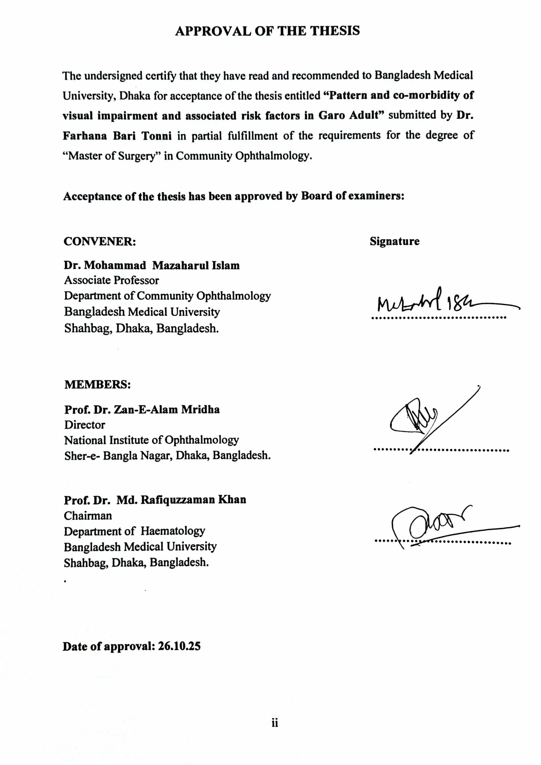
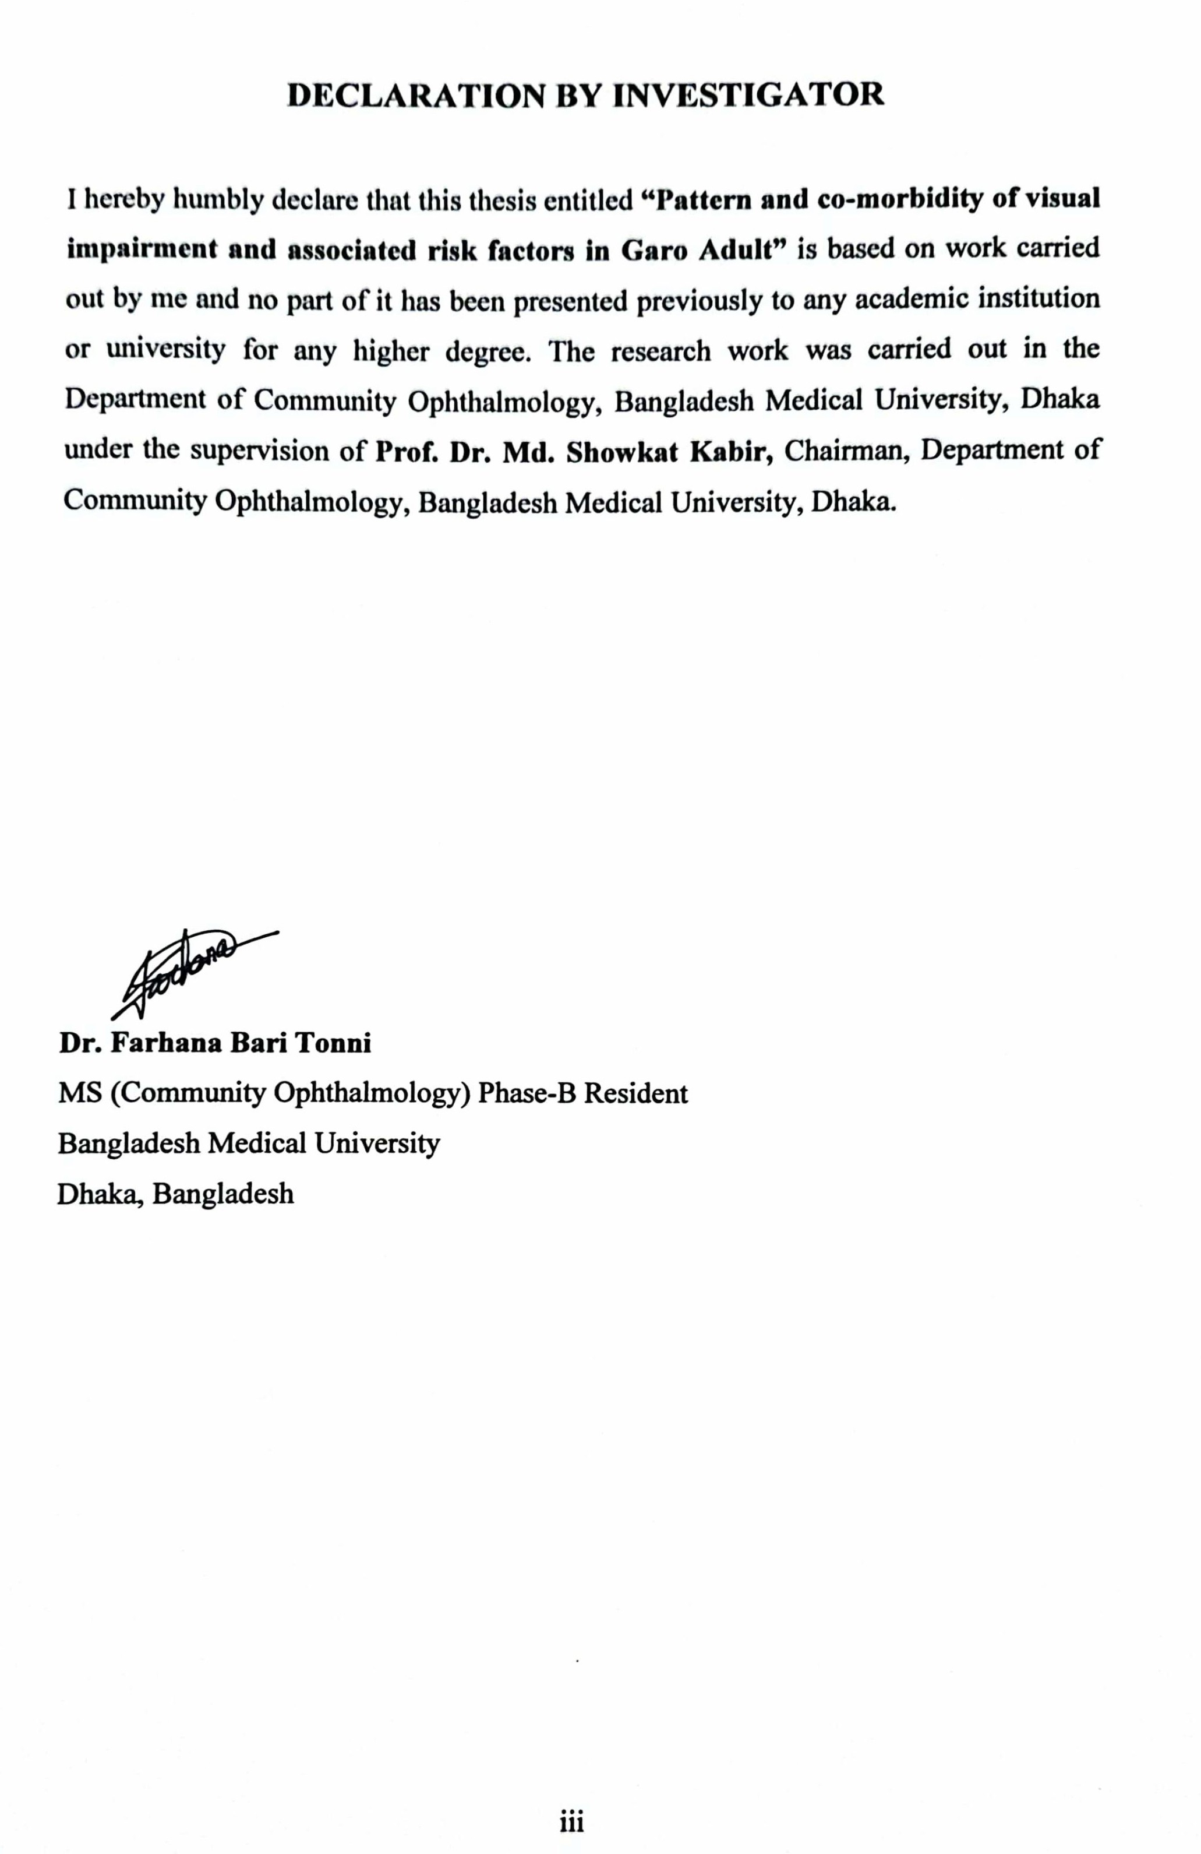
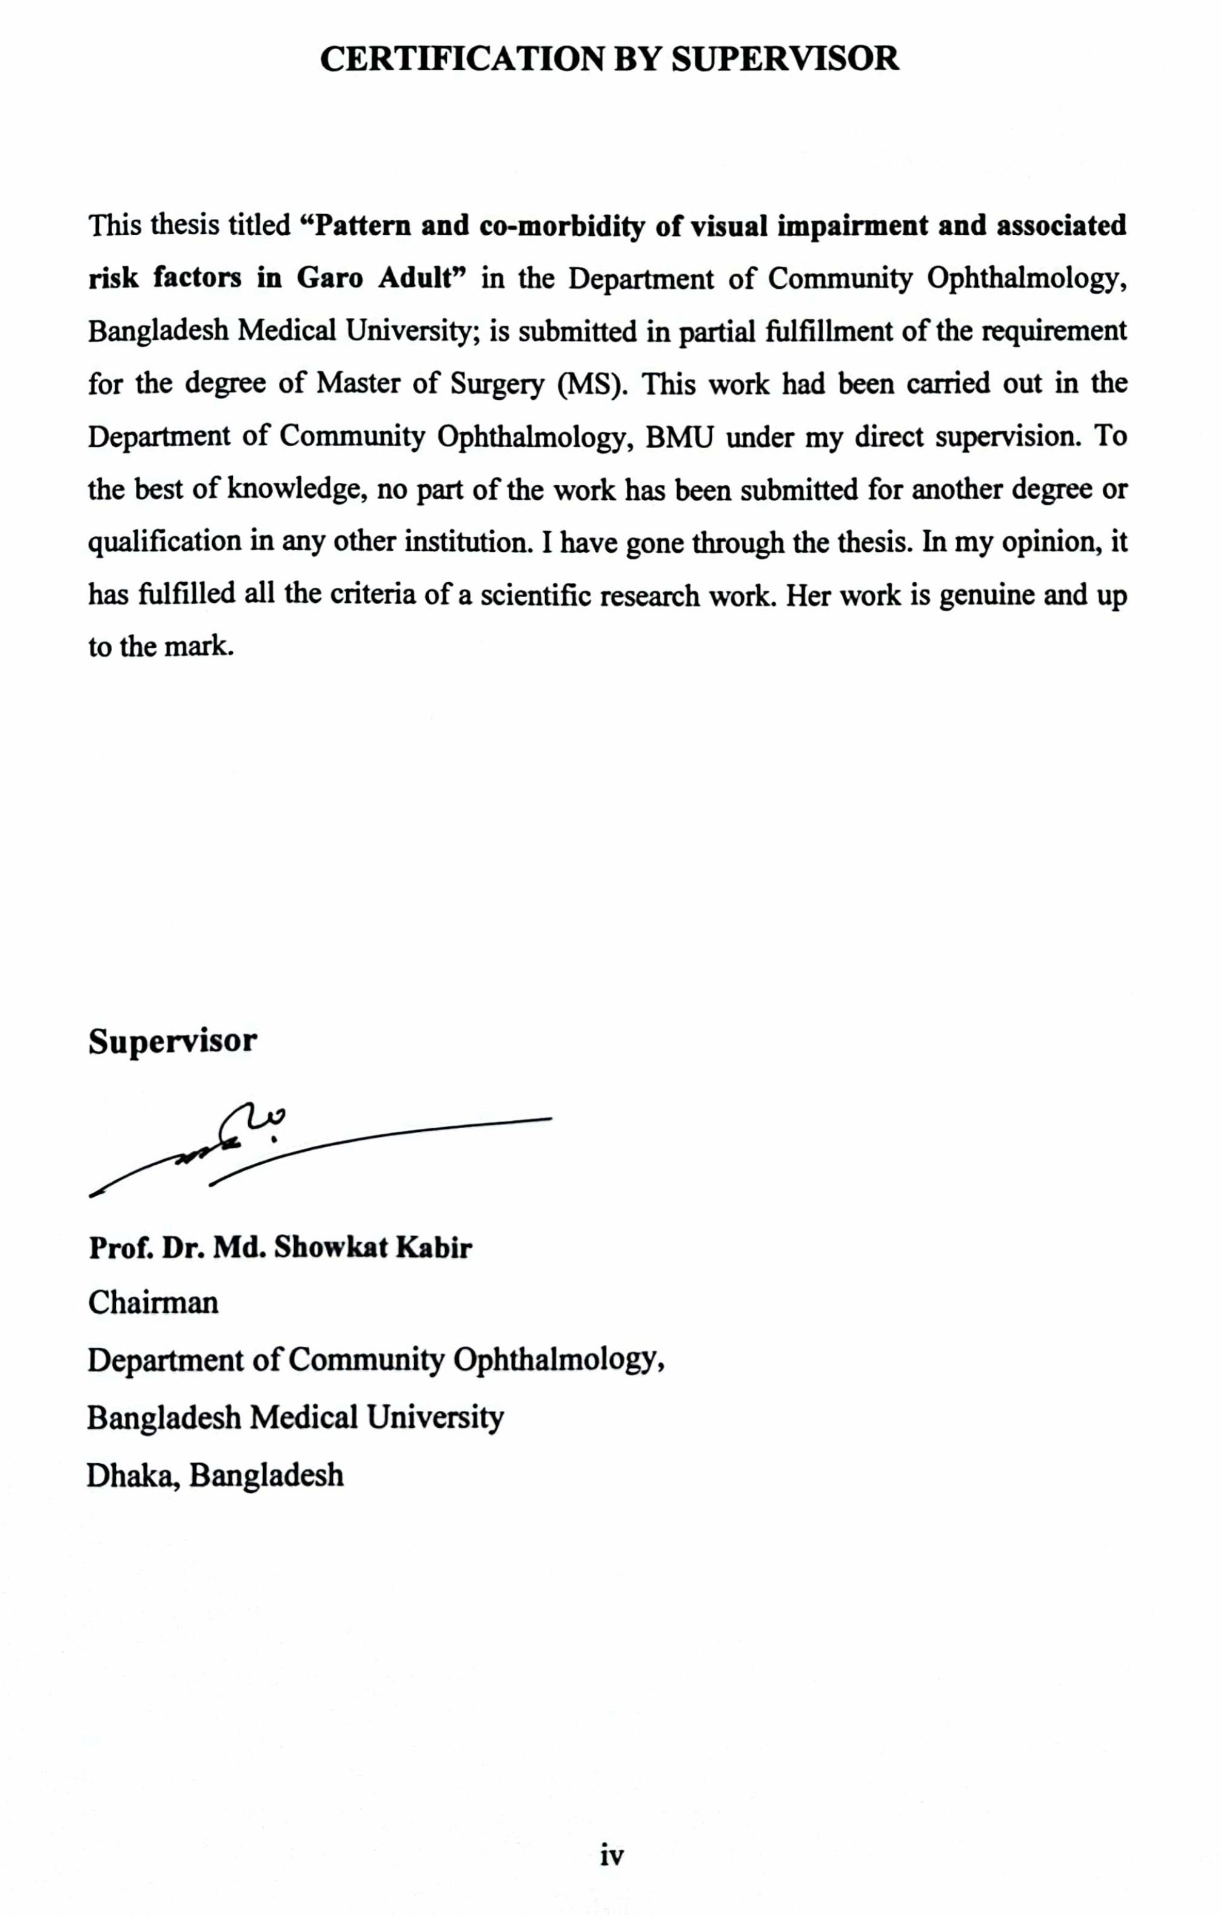
iv
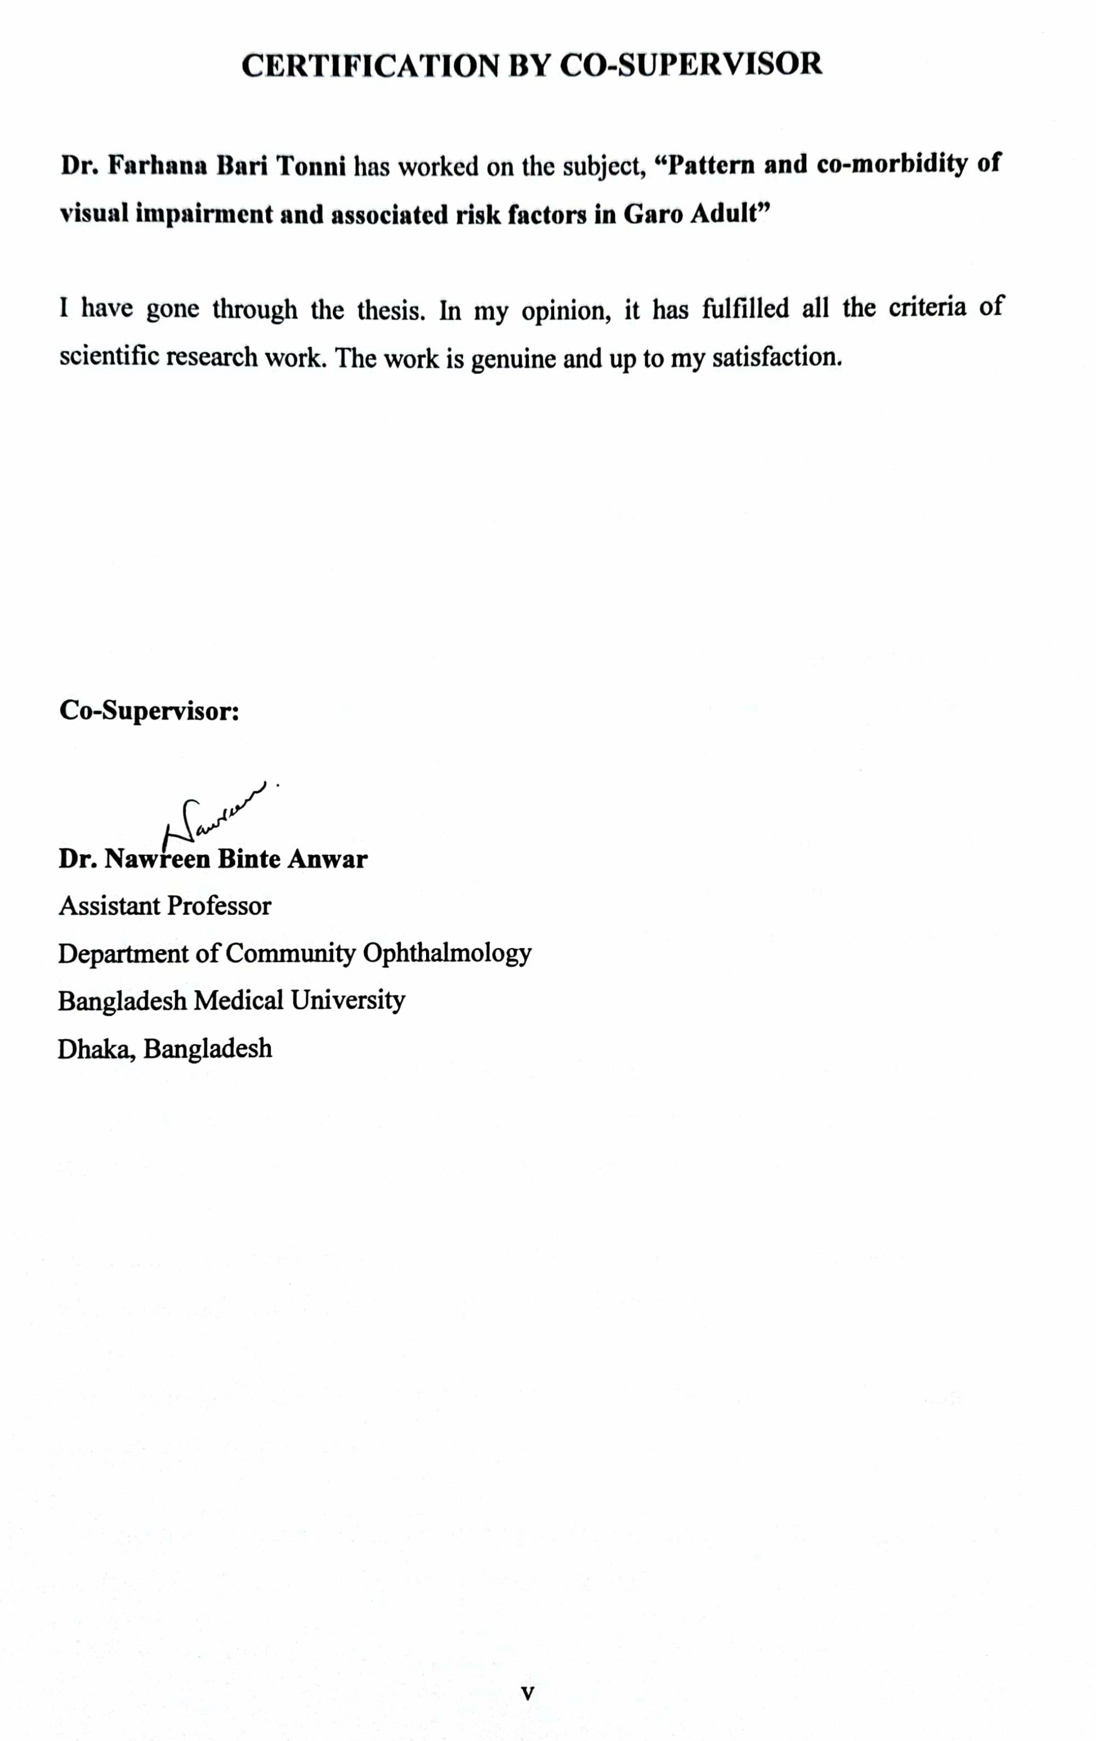
v

ACKNOWLEDGEMENTS

First and foremost, I must keep in mind and state my enormous gratitude to Almighty, for giving me the ability and opportunity to complete this thesis work.

With utmost regards, I owe my heartiest gratitude and indebtedness to my supervisor Prof. Dr. Md. Showkat Kabir, Chairman, Department of Community Ophthalmology, BMU, Dhaka for his close supervision, constant courage and scholarly support from the protocol proposal till the completion of the study. I feel fortunate to work under his guidance and am thankful for his valuable suggestions throughout my study.

I extend my whole hearted gratitude and special thanks to my co-supervisor Dr. Nawreen Binte Anwar, Assistant Professor, Department of Community Ophthalmology, BMU, for her valuable supervision and constant support in my study.

I must express my sincere gratitude & special thanks to my honorable teacher prof. Sayed Shariful Islam, Department of Public Health and Informations, BMU, Dhaka for his kind cooperation in preparing my thesis. Otherwise it would be difficult for me to complete my thesis work.

I must express my sincere gratitude & special thanks to my honorable teacher Dr. Nirupam Chowdhury, Assistant Professor Department of Community Ophthalmology, BMU, Dhaka for his kind cooperation in topic selection of my thesis.

I would like to express my gratitude to the Chairman of Pirgacha and the local people who co-operated and responded to my study wholeheartedly.

I am thankful to the thesis grant committee, BMU to give financial support to complete my research work.

I put my highest regards to all my study population, who gave their consent without any hesitation for all examinations and investigations.
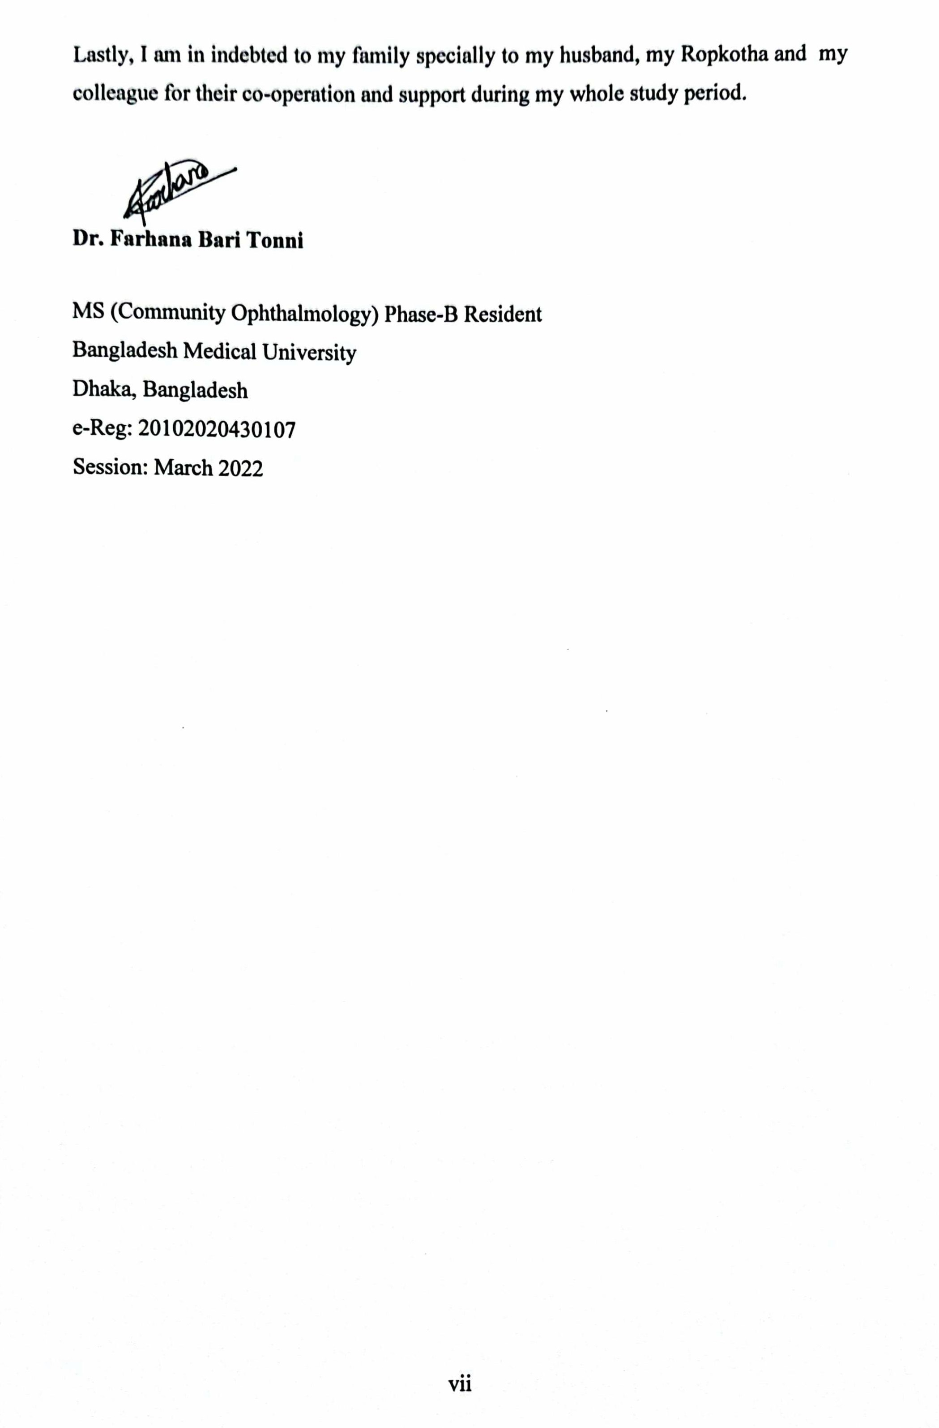
vii

LIST OF CONTENTS

Subjects Page
CHAPTER 1 INTRODUCTION 1-5
  - Introduction 1
  - Rationale 3
  - Research question 4
  - Objectives 5
CHAPTER 2 LITERATURE REVIEW 6-8
- Literature review 6
CHAPTER 3 MATERIALS & METHODS 9-16
CHAPTER 4 RESULTS 17-33
CHAPTER 5 DISCUSSION 34-42
  - Discussion 34
  - Conclusion 40
  - Limitations 41
  - Recommendations 42
CHAPTER 6 REFERENCE 43-48
CHAPTER 7 APPENDICES xiv-
Appendix -I: IRB Clearance Certificate xiv
Appendix -II: Informed Written Consent xv
Appendix -III: Data collection Sheet xix
Appendix -IV: Work schedule xxiii
Appendix -V: Flowchart xxiv
Appendix -VI: Detailed budget xxv
Appendix -VII: Snellen’s to Log MAR Conversion Chart xxvi
Appendix -VIII: Modified Kuppuswamy socioeconomic scale xxvii
Appendix -IX: Statistical Formulae xxviii
Appendix -X: Acceptance letter from local chairman xxix
Appendix -XI: Certificate of Plagiarism Check xxx

LIST OF TABLES

Sl. No. Title Page

Table I Distribution of the study populations according to education
20
level
Table II Distribution of the study populations according to co-
21
morbidity
Table III Distribution of the study populations according to risk factors 22
Table IV Distribution of the study populations according to visual acuity 23
Table V Distribution of the study populations according to presbyopia 25
Table VI Distribution of the study populations according to emmetropia 26
Table VII Distribution of the study populations according to vision not
27
improved
Table VIII Distribution of the study populations according to posterior
29
segment diseases
Table IX Multivariate analysis for refractive error 31
Table X Multivariate analysis for anterior segment diseases 32
Table XI Multivariate analysis for posterior segment diseases 33

LIST OF FIGURES

Sl. No | Title | Page
Figure 1 | Bar diagram shows the age of study populations | 18
Figure 2 | Pie chart shows the sex of study populations | 19
Figure 3 | Bar diagram shows the refractive error of study populations | 24
Figure 4 Bar diagram shows the anterior segment diseases of study
28
populations
Figure 5 Bar diagram shows the ocular diseases and refractive error of study
30
populations

LIST OF ABBREVIATIONS

BCVA | Best Corrected Visual Acuity
BMU | Bangladesh Medical University
CS | Contrast Sensitivity
CV | Color Vision
F | Female
IRB | Institutional Review Board
LE | Left eye
M | Male
OPD | Out Patient Department
OR | Odds Ratio
PVA | Presenting visual acuity
RAAB | Rapid Assessment of Avoidable Blindness
RE | Right eye
SVI | Severe visual impairment
SD | Standard Deviation
SPSS | Statistical Package for Social Science
UDVA | Uncorrected Distant Visual Acuity
VA | Visual Acuity
VF | Visual Field
WHO | World Health Organization

Abstract
Background: Visual impairment is a major public health issue, especially in indigenous groups with limited healthcare access and socioeconomic disadvantage. The Garo population may be particularly vulnerable due to cultural and lifestyle factors, making it important to explore patterns, co-morbidities, and risk factors in this community.

Objective: To determine the pattern and co-morbidity of visual impairment and associated risk factors in Garo tribe.

Methods: This cross-sectional study was conducted in Pirgacha, Madhupur, in the Tangail district under the supervision of the Department of Community Ophthalmology, BMU, Dhaka. People who met the criteria for inclusion were selected for the study population. A total of 130 patients were enrolled. Informed written consent was obtained from each participant. Demographic information, relevant history, and other details were recorded using a structured questionnaire. Complete clinical evaluation, including history, systemic examination, and ocular examination, was performed. Statistical analysis was carried out using Statistical Package for Social Science 27.0 (SPSS; Chicago, Illinois), and p-values of less than
0.05 were considered statistically significant.

Results: A total of 111 Garo adults were examined. The largest age group was 18–30 years (39.6%), with females slightly predominating (52.2%). Hypertension (13.5%) was the most common comorbidity, and alcohol use was frequent (66.7%). Family history of ocular disease was present in 38.7%. Moderate visual impairment was observed in 16.2% (right) and 15.3% (left eyes), with severe impairment in 9.0% and 7.2%, respectively. Refractive errors were common (50.5%), with presbyopia in 35.1%. Anterior segment diseases, mainly cataract, were most prevalent (55.0%), while posterior segment diseases were less frequent (9.0%). Multivariate analysis showed refractive errors were significantly associated with age, female sex, and family history of ocular disease; anterior segment disease was associated with age. No significant predictors were identified for posterior segment disease
Conclusions: Visual impairment in Garo adults is mainly linked to demographic factors, ocular diseases, and lifestyle habits. Cataract, refractive errors, and presbyopia were common causes, with hypertension and diabetes as key co-morbidities. Age, sex, and family history emerged as significant predictors, emphasizing the need for early detection and prevention.

Keywords: ocular morbidity, Garo adults, Risk factors, visual impairment, cataract.

Introduction

Visual impairment is a remarkable health problem affecting the majority of people worldwide (Gangadhar et al., 2023). In 2020, about 43 million individuals were blind, while 295 million experienced moderate to severe distance vision impairment, 258 million had mild distance vision impairment, and 510 million were affected by near vision impairment. (R.B.Rezayee et al., 2024).

It is a global load which is distributed haphazardly and some region have higher load compare with others. Indian subcontinent region contributes maximum global blindness and moderate to Severe visual impairment. The south Asia has 12 million blind people and 61 million people with moderate to severe VI (Malhotra et al., 2018).

According to World Health Organization (WHO) (2010), around 39 million people worldwide were blind, with cataract (51%), glaucoma (8%), and age-related macular degeneration (5%) identified as the leading causes. By 2020, an estimated 596 million people were living with distance vision impairment globally, including 43 million who were blind. Additionally, about 510 million people experienced uncorrected near vision impairment due to the lack of reading spectacles (R.B. Rezayee et al., 2024).

A maximum proportion of those affected (90%), live in low income and middle-income countries (LMICS) (Lancet glob health 2020). Bangladesh, a south Asian country is one of cultural and ethnic diversity, with 50 indigenous communities; along with the majority of Bangali population. According to census of 2022, the country’s indigenous population is approximately 16,50,159 which represent 1% of total population of the country. (Kabir et al., 2022)

According to the data of several research and reports, these ethnic communities are often considered the “marginalized population”. The Garo represent one of the largest indigenous communities in the country, predominantly residing in the north-eastern districts such as Gazipur, Mymensingh, Netrokona, Tangail, Sherpur, and Jamalpur (Kabir et al., 2022).
However, indigenous people are deprived of basic rights and they are regarded as the poor, illiterate and backward populations of the country. (Dhake, et al.,2011)

Due to limited education and lack of awareness, many ethnic communities remain uninformed about their health and overall wellbeing. Factors such as illiteracy, poor working conditions, and traditional practices including smoking, alcohol use, and dependence on locally brewed liquor contribute to their vulnerability to various diseases. Moreover, low economic status, inadequate education, limited healthcare spending, and the presence of multiple health conditions are significant contributors to higher mortality among minority groups (Tewari et al., 2009; Kinsey et al., 2008; Albano et al., 2007).

Eye health is recognized as a global priority, with the potential to transform lives across both low- and high-income settings. It should therefore be viewed not only as a health concern but also as a key development issue, deserving strong integration into national health and development agendas. People with visual impairment face a greater risk of poverty, even though over 80% of visual impairment worldwide is preventable or treatable. Evidence also shows that cataract surgery significantly enhances quality of life and increases household income, as demonstrated in the PROSPER trial on presbyopia correction in rural populations. (R.B.Rezayee et al., 2024).

The aim of the study is to assess the pattern and co-morbidity of visual impairment and associated risk factors in Garo Adult. This study will help the Garo tribe to raise awareness about the routine eye examination and pave the way of further research.

Rationale of the study

The Garo people have a community of their own apart from the mainstream. Due to the traditional lifestyle and poor socio-economic condition they have to spend the majority of their entire income for food, leaving health requirements unmet, particularly eye ailments. Detecting Garo eye health problems is important for identifying eye disorders, planning targeted interventions, ensuring early intervention and treatment, preventing permanent vision loss and improving health indices of Garo population. In BD, few studies have been carried out on the relationship between pattern and co-morbidity of eye diseases and associated risk factors among Garo tribe. Therefore this current study will enrich the various aspect of further studies about this ethnic people and foresee the community eye health care plan by focusing their ocular health condition.

Research question

What are the patterns and co-morbidities of visual impairment and associated risk factors among Garo tribe in Madhupur, Tangail, Bangladesh?

Objectives

    - General Objective:

To determine the patterns and co-morbidities of visual impairment and associated risk factors among Garo tribe.

Specific Objective:

      - To assess the refractive status of Garo tribe.

      - To assess Anterior segment diseases of Garo tribe.

      - To assess Posterior segment diseases of Garo tribe.

      - To see the associations of co-morbidities related to eye disease.
      - To see the associations between risk factors & co-morbidity with causes of visual impairment.

Literature Review

Majhi et al. (2023) assessed 9,872 Dongaria tribals in Odisha through door-to-door surveys and reported 12.4% visual impairment, with refractive error (7.5%) and cataract (7.6%) as leading causes. High illiteracy (86%), alcohol intake (62%), poor nutrition, and vitamin A deficiency in children (20%) were significant contributors. The findings highlight the multifactorial nature of visual impairment in tribal groups, shaped by biological, behavioral, and social determinants, with implications for Garo adults.

Singh et al. (2014) conducted a large community-based study in tribal regions of Andhra Pradesh using RAAB methodology, assessing 7,281 adults aged ≥50 years with a 97.1% response rate. The prevalence of visual impairment (VI), severe VI, and blindness based on presenting vision was 16.9%, 2.9%, and 2.3%, respectively, which reduced to 6.2%, 1.5%, and 2.1% after pinhole correction. Refractive errors were the leading cause of VI (71.4%), while cataracts predominated in severe VI and blindness (70.3%). Risk factors for blindness included increasing age, illiteracy (OR=4.3), and female gender (OR=1.3), while spectacle use was protective (OR=0.2). This study underscores the high burden of avoidable blindness in tribal populations and the importance of modifiable factors such as education and access to corrective eyewear, providing relevant context for comparison with Garo adults.

Banik and Gouala (2021) investigated the housing and settlement characteristics of the Garo ethnic community in Haluaghat, Mymensingh, in order to understand their spatial patterns of living and associated cultural implications. According to their abstract, the study emphasized that housing structures among the Garo were not only a matter of architecture but also indicators of cultural continuity and environmental adaptation. These findings are relevant to health conditions such as visual impairment, since poorly lit traditional houses and smoke from wood-fired cooking could increase ocular health risks. Thus, environmental living conditions described in this study offer important background to understanding visual impairment risk factors in the Garo population.

Malhotra et al. (2018) conducted a cross-sectional study in rural Haryana among adults ≥50 years and found a 24.5% prevalence of visual impairment. Uncorrected
refractive error (50%) and cataract (37%) were the leading causes, while age, gender, education, and marital status emerged as key determinants. The study highlights avoidable causes and socio-demographic risks, offering parallels for vulnerable tribal populations.

Shriraam et al., (2021) reported a rising burden of NCDs obesity, diabetes, and hypertension among tribal populations in South India. These conditions contribute to ocular morbidity, including diabetic and hypertensive retinopathy, with many cases likely underdiagnosed due to limited healthcare access, highlighting systemic diseases as important contributors to visual impairment in tribal adults.

Dhake et al., (2011) conducted a population-based survey in Nandurbar, a tribal district of Maharashtra, India, to determine the prevalence and causes of avoidable blindness and severe visual impairment among adults aged 50 and above using the Rapid Assessment for Avoidable Blindness (RAAB) methodology The main barrier reported for untreated cataract was a lack of awareness, cited by 41% of participants. These findings underscore the urgent need to address treatable causes of blindness through accessible and affordable cataract surgery and awareness campaigns, especially in underprivileged tribal communities.

Gangadhar et al., (2023) explored the clinical profile and preventable causes of permanent visual impairment among individuals seeking disability certification in a tribal district of central India. This study focused on individuals with permanent visual disabilities, often caused by non-treatable conditions. The study highlights a different dimension of visual impairment where irreversible causes dominate, emphasizing the need for better early intervention, trauma prevention, and policy changes to include one-eyed individuals in support systems. It also stresses the importance of comprehensive ophthalmic services in tribal settings.

Kabir et al., (2022) carried out an ethnographic case study to investigate the livelihood patterns and sociocultural challenges faced by the Garo community in a village in Tangail District, Bangladesh. The paper points out that despite the Garo community's contributions to cultural diversity, they are frequently deprived of socioeconomic and civil services, making them one of the most marginalized ethnic groups.
Dineen et al., (2003) conducted a national survey in Bangladesh among adults ≥30 years (n=11,624, 90.9% response) to assess visual impairment and blindness. They found an age-standardized prevalence of bilateral blindness of 1.53% and binocular low vision of 13.8%. Cataract was the leading cause of both blindness (79.6%) and low vision (74.2%), followed by refractive errors (18.7%) and macular degeneration. The study highlighted the predominance of treatable causes and stressed the need for national eye care programs to address cataract and refractive error burdens.

Singh et al., (2021) studied 7,133 individuals in North-East India and found diabetic retinopathy (DR) prevalence of 30% among diabetics, with vision-threatening DR in 10%. Prevalence was highest in immigrant groups and lowest among tribal groups, indicating possible ethnic influence. Major risk factors included longer diabetes duration, poor glycemic control, hypertension, and hypertriglyceridemia. The study underscores the role of ethnicity and systemic comorbidities in shaping DR risk.

Warkad et al., (2018) screened 10,038 tribal children in Odisha and found refractive error (59.5%) as the leading cause of visual impairment, followed by amblyopia (17.2%) and posterior segment anomalies (14.9%). Severe visual loss was rare (0.13% had ≤ 20/40 vision; 0.03% blind). The study highlights the importance of early detection in tribal communities to prevent long-term visual disability.

Materials and methods:

  - Study design: Cross sectional observational study

  - Place of study: Pirgacha, Madhupur, Tangail.

  - Study period: December 2023 to september 2025( data collection from June 2024 to July 2025)

  - Study population: This study was conducted among the Garo tribe in Pirgacha, Madhupur, Tangail.

  - Sampling technique: Purposive sampling technique

  - selection criteria: The selection was on the basis of the following criteria:

Inclusion criteria

      - Participants must belong to the Garo tribe.

      - Age limit:18 years and above

      - Both male and female genders

Exclusion Criteria:

      - Individuals below 18 years of age

      - Non-Garo individuals

      - Individuals who are not permanent residents of the study area

      - Individuals with severe systemic illness precluding complete ocular examination
      - Uncooperative individuals or those unable to complete the required examination and questionnaire

Sample size

Sample Size: The sample size was determined by following formula (chow, wang and shao 2007)

Where,

n = The desired sample size
π= 16% or 0.16(Population proportion under alternate hypothesis)
π0= 8% or 0.08(Population proportion under null hypothesis) u = 1.96 (Reject H˳ If Z >1.9600)
v = 0.84 (Z value at 80% power)
π-π˳= The difference to be detected by the study.

So, the calculated sample size was 111.

Variables of the Study:

Socio-demographic variables:

- Age

- Sex

- Education

- Status of housing

- Use of sanitary latrine

- Proper nutrition

Clinical variables:

- Refractive status

- Anterior segment diseases

- Posterior segment diseases

- Co-morbidities (DM, HTN)

- Risk factors

  - Smoking

  - Alcohol

  - Betel nut/ leaf

  - History of ocular diseases

  - History of ocular injury

  - Family history of ocular diseases

  - Family history of systemic diseases

operational definition:

Tribe: The term "tribe" is broadly defined in anthropology and sociology as a social group existing before the development of or outside of states, typically characterized by Shared ancestry or kinship, Common language or dialect, Distinct cultural practices, Occupation of a specific territory, social organization often based on clans or segmentary lineages. (Akhter et al.,2020)

Visual impairment: This study followed WHO definitions for visual impairment considering it presence when visual acuity was less than 6/12 in the better eye. It included mild (VA <6/12 and > 6/18), moderate (VA <6/18 and > 6/60), and severe impairment (VA <6/60 and >3/60) as well as blindness. (Malhotra et al.,2018)

Refractive error: In contrast to emmetropia the ametropic eye fails to bring parallel light to a focus on the retina. When an individual’s visual acuity in snellen score was
≤6/9(20/25) in either or both eyes and or corrected with spectacles/contact lens or ametropia according to retinoscopic findings was considered as refractive error.

Anterior segment of eye: The anterior segment refers to the front-most region of the eye, and includes the cornea, iris, and lens, anterior chamber and part of posterior chamber.

Posterior segment of eye: The posterior segment of the eye comprises the back two-thirds of the eye, including the vitreous humor, the retina, the choroid and the optic nerve.

Study procedure and design:

A cross sectional study was carried out in Garo tribe under Tangail district of Bangladesh under the supervision of Department of Community Ophthalmology, BMU, Dhaka.

The details of the research project was discussed with the local chairman and a letter explaining the objectives were given.
This study was conducted over a period of one year (from June2024 to July 2025) among the Garo tribe in Pirgacha, Madhupur Tangail district, aged 18 and above.
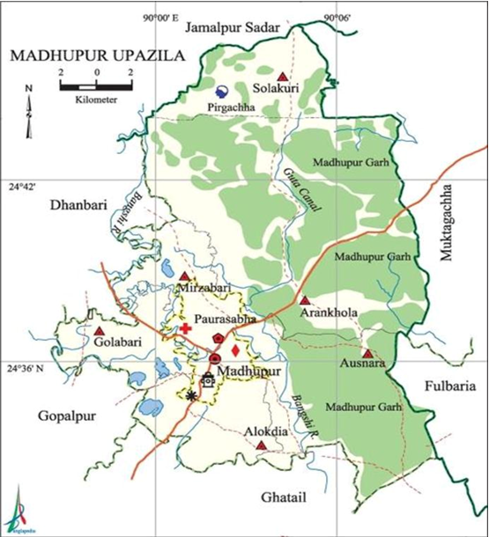
Screening was carried out to find out the eligible tribe member, and the respondents were interviewed personally.

The demographic data, medical and ophthalmic history including the history of probable risk factors were collected using a semi-structured pre-tested questionnaire.

Informed written consent was obtained from each participant.
Visual acuity was tested each eye separately using occluder with Snellen chart in a properly lighted place from 6meter distance. Pinhole test was performed to determine further improvement of vision. If the subject could read one or more lines on the chart with pinhole, it was suggested that the vision could be improved by refraction and spectacles were prescribed BCVA after retinoscopy. Vision was assessed with glasses whenever a subject uses it. VA was carried out using a Snellen chart and converted to Log MAR by using an online Snellen to Log MAR visual acuity calculator.

Near vision testing with both eyes together using an N-type handheld chart at a distance of 40 cm.

Ocular examination includes Hirschberg reflex, Pupillary light reaction, Anterior segment examination were conducted with torch light and hand-held slit lamp .

Fundus examination was done using Heine 200s direct ophthalmoscope to evaluate the posterior segment.

The subjects who need further medical or surgical treatment was referred to the Community Ophthalmology department of BMU.

Data Collection, processing & analysis:

The demographic information, relevant history, examination findings, fundus examination all the study subjects was recorded in the data collection sheet.

Data analysis plan:

Data were analyzed using the Statistical Package for Social Science (SPSS) version
27.0 (IBM Corp., Armonk, NY, USA). Continuous variables were presented as mean
± standard deviation, while categorical variables were expressed as frequencies and percentages. Multivariate analysis was performed for refractive error, anterior segment diseases, and posterior segment diseases. The data were presented in the form of tables, figures, and graphs. A p-value of less than 0.05 was considered statistically significant.

Ethical consideration:

The research protocol was approved by the IRB (BSMMU/2024/5576) of BMU before starting this study. The purpose and procedures were briefly explained to all participants. Informed written consent (English/Bengali version) was taken from each patient. The participants were having freedom to refuse to answer any question. Final data base and report was not containing the name of participants. There was minimum chance of any physical adverse effects. There is hardly any possibility of mental or social harm in the participation of the study. All the participants were treated with available resource. All sorts of confidentiality were ensured. No money was given to the participants of the study.

Informed Consent:

For this study, a well-informed, voluntarily signed written consent was taken in an understandable local language from the study subjects guardian after convincing them that their privacy & confidentiality was safeguarded. Proper treatment facilities were available to manage any injury/ complications as a result of this study.

Confidentiality:

To maintain Confidentiality, each of the study subjects was given a special ID number which was followed during each and every step of the study procedure. All the research data was coded and stored in a locked cabinet. Only research personnel were allowed to access the data. Privacy was maintained during physical examination & interview and also at the time of procedure.

Use of drugs:

No experimental drugs or placebo was used for this study.

Results:

This cross-sectional study was conducted to determine the pattern and co-morbidity of visual impairment and associated risk factors among the Garo tribe. A total of 111 participants from the Garo community in Pirgacha, Madhupur, Tangail, were included in the study. The research was carried out under the supervision of the Department of Community Ophthalmology, Bangladesh Medical University (BMU), Dhaka, from June 2024 to July 2025. Informed written consent was obtained from each participant prior to their inclusion. The inclusion criteria consisted of individuals aged 18 years and above, of both sexes, who belonged to the Garo tribe in Madhupur, Tangail. Individuals below 18 years of age, non-Garo individuals, those who are not permanent residents of the study area, individuals with severe systemic illness that precluded complete ocular examination, and those who were uncooperative or unable to complete the required examination and questionnaire were excluded from the study. Demographic information, relevant history, and clinical data were collected using a semi-structured questionnaire. A complete clinical evaluation was performed, which included medical history-taking, systemic examination, and a detailed ocular examination.
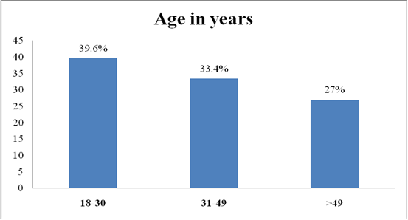

Figure 1: Bar diagram shows the age of study populations
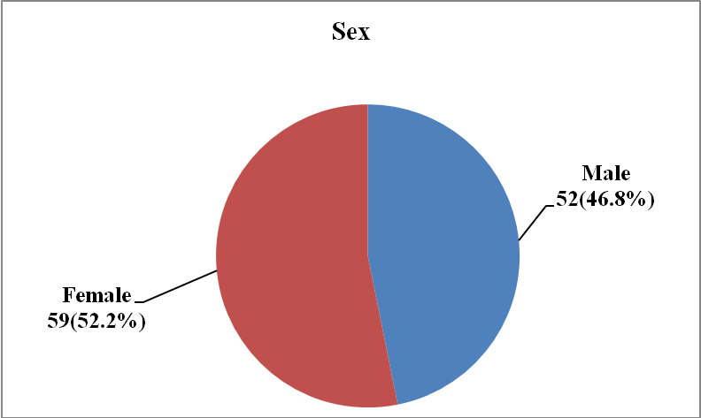

Figure 2: Pie chart shows the sex of study populations
Table I: Distribution of the study populations according to Education level (N=111)

Education level | Number of populations (n) | Percentage (%)
Illiterate | 22 | 19.8
Primary school | 9 | 8.1
Middle school | 7 | 6.3
High school | 27 | 24.3
Intermediate/diploma | 33 | 29.7
Graduate | 13 | 11.7
Professional degree | 0 | 0.0

Table II: Distribution of the study populations according to co-morbidity (N=111)

Co-morbidity | Number of populations (n) | Percentage (%)
HTN  Yes | 15 | 13.5
No | 96 | 86.5
DM  Yes | 7 | 6.3
No | 104 | 93.7

Table III: Distribution of the study populations according to risk factors (N=111)

Risk factors | Number of populations (n) | Percentage (%)
Past history  History of ocular diseases | 9 | 8.1
History of ocular surgery | 12 | 10.8
History of ocular injury | 9 | 8.1
Personal history  Smoking | 34 | 30.6
Alcohol consumption | 74 | 66.7
Betel Nut/ leaf | 32 | 28.8
Family history  Ocular disease | 43 | 38.7
HTN | 28 | 25.2
DM | 4 | 3.6
Fatty liver | 1 | 0.9
Status of housing
Brick | 84 | 75.7
Bamboo | 12 | 11.7
Wood | 14 | 12.6
Use of sanitary latrine  Yes | 96 | 86.5
No | 15 | 13.5
Proper nutrition  Yes | 94 | 84.7
No | 15 | 13.5

Table IV: Distribution of the study populations according to visual acuity

(N=111)
Visual acuity (Log MAR) |  | Right eye |  |  | Left eye
0.0 | N  54 |  | %  48.6 | N  56 |  | %  50.5
0.17 | 20 |  | 18.0 | 16 |  | 14.4
0.30 | 9 |  | 8.1 | 14 |  | 12.6
0.47 | 4 |  | 3.6 | 7 |  | 6.3
0.60 | 2 |  | 6.3 | 2 |  | 1.8
0.77 | 3 |  | 2.7 | 3 |  | 2.7
1.00 | 4 |  | 3.6 | 5 |  | 4.5
2.00 | 10 |  | 9.0 | 8 |  | 7.2
Mean±SD |  | 0.35±0.58 |  |  | 0.31±0.54
Range (Min-Max) |  | 0-2 |  |  | 0-2

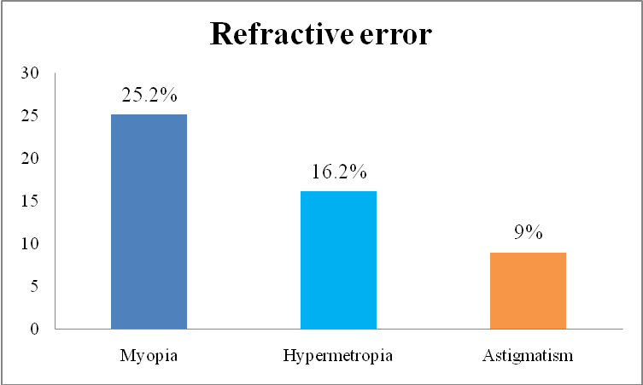

Figure 3: Bar diagram shows the refractive error of study populations
Table V: Distribution of the study populations according to presbyopia(N=111)

Presbyopia | Number of populations (n) | Percentage (%)
Yes | 39 | 35.1
No | 72 | 64.9

Table VI: Distribution of the study populations according to emmetropia (N=111)
Emmetropia | Number of populations (n) | Percentage (%)
Yes | 31 | 27.9
No | 80 | 72.1

Table VII: Distribution of the study populations according to vision not improved (N=111)
Vision Not improved | Number of populations (n) | Percentage (%)
Yes | 6 | 5.4
No | 105 | 94.6

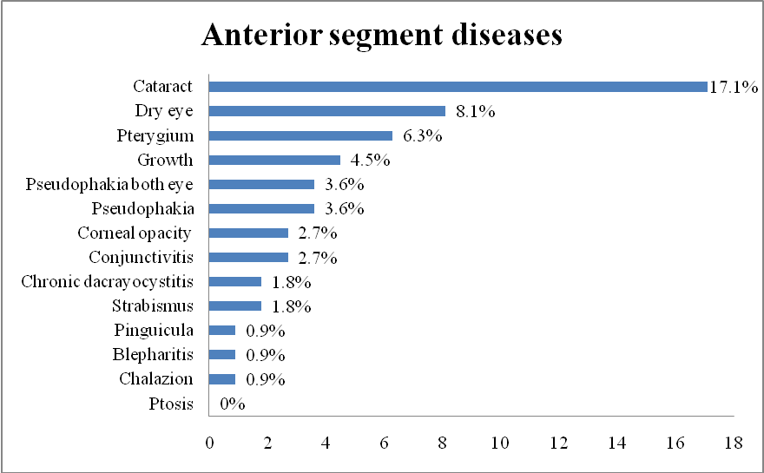

Figure 4: Bar diagram shows the anterior segment diseases of study populations
Table VIII: Distribution of the study populations according to posterior segment diseases (N=111)
Posterior segment diseases | Number of populations (n) | Percentage (%)
Myopic fundus | 5 | 4.5
Glaucoma | 3 | 2.7
Diabetic retinopathy | 1 | 0.9
Age related macular degeneration | 1 | 0.9

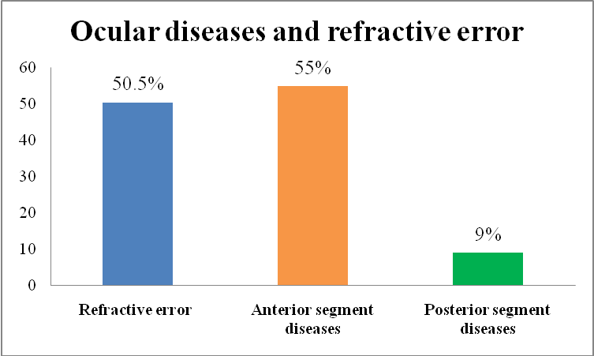

Figure 5: Bar diagram shows the ocular diseases and refractive error of study populations
Table IX: Multivariate analysis for refractive error

P value OR 95% CI

 |  |  | Lower | Upper
Age | 0.023^{s} | 0.957 | 0.921 | 0.994
Sex | 0.039^{s} | 3.537 | 1.065 | 11.745
History of ocular diseases | 0.174^{ns} | 5.29 | 0.48 | 58.269
History of ocular injury | 0.542^{ns} | 1.687 | 0.314 | 9.055
Smoking | 0.060^{ns} | 0.291 | 0.077 | 1.102
Alcohol | 0.164^{ns} | 0.429 | 0.13 | 1.413
Betel Nut/ leaf | 0.121^{ns} | 2.579 | 0.778 | 8.551
Family history of ocular disease | 0.002^{s} | 5.155 | 1.835 | 14.482
Family history of systemic disease | 0.841^{ns} | 0.887 | 0.277 | 2.841
Status of housing | 0.204^{ns} | 1.972 | 0.692 | 5.619
Use of sanitary latrine | 0.545^{ns} | 1.843 | 0.254 | 13.357
Proper nutrition | 0.545^{ns} | 1.843 | 0.254 | 13.357
s=significant ns=not significant

Table X: Multivariate analysis for anterior segment diseases

P value OR 95% CI

 |  |  | Lower | Upper
Age | 0.001^{s} | 0.93 | 0.891 | 0.971
Sex | 0.781^{ns} | 0.841 | 0.247 | 2.86
History of ocular diseases | 0.810^{ns} | 0.767 | 0.087 | 6.729
History of ocular injury | 0.153^{ns} | 4.412 | 0.576 | 33.773
Smoking | 0.157^{ns} | 2.809 | 0.672 | 11.739
Alcohol | 0.710^{ns} | 0.786 | 0.221 | 2.801
Betel Nut/ leaf | 0.576^{ns} | 1.421 | 0.414 | 4.872
Family history of ocular disease | 0.061^{ns} | 0.301 | 0.085 | 1.057
Family history of systemic disease | 0.125^{ns} | 3.17 | 0.726 | 13.845
Status of housing | 0.885^{ns} | 0.934 | 0.368 | 2.368
Use of sanitary latrine | 0.252^{ns} | 0.287 | 0.034 | 2.426
Proper nutrition | 0.252^{ns} | 0.287 | 0.034 | 2.426

s=significant ns=not significant

Table XI: Multivariate analysis for posterior segment diseases

P value OR 95% CI

 |  |  | Lower | Upper
Age | 0.088^{ns} | 0.956 | 0.908 | 1.007
Sex | 0.819^{ns} | 0.82 | 0.15 | 4.479
Alcohol | 0.637^{ns} | 0.633 | 0.095 | 4.227
Betel Nut/ leaf | 0.429^{ns} | 0.458 | 0.066 | 3.167
Family history of systemic disease | 0.224^{ns} | 2.822 | 0.529 | 15.042
Status of housing | 0.788^{ns} | 0.819 | 0.192 | 3.503
Use of sanitary latrine | 0.266^{ns} | 0.231 | 0.018 | 3.045
Proper nutrition | 0.266^{ns} | 0.231 | 0.018 | 3.045

ns=not significant

Discussion

Visual impairment is a multifactorial condition influenced by demographic, genetic, lifestyle, and environmental determinants (Gangadhar et al., 2023). Age-related changes remain a dominant cause, with cataract, refractive errors, and presbyopia contributing substantially to vision loss in adult populations (Majhi et al., 2023; Warkad et al., 2023). Lifestyle practices such as tobacco use, alcohol consumption, and betel nut chewing have been linked to increased ocular morbidity (Khanna et al., 2021; Mahesh et al., 2019; Ray et al. 2018). Familial predisposition to ocular and systemic diseases amplifies susceptibility (Chariwala et al., 2021). Socioeconomic indicators, including housing type, sanitation access, and nutrition, further shape disease patterns (Malhotra et al., 2018; Naidoo and Jaggernath 2012). Targeted interventions addressing modifiable risks could reduce preventable vision loss (Shriraam et al., 2021; Dhake et al., 2011).

The present study reported that the largest proportion of participants were aged 18–30 years (39.6%) with a mean age of 39.7±15.4 years. In a study on visual impairment in tribal district of central India, Gangadhar et al., (2023) found similar age distribution. In contrast, Majhi et al., (2023) studied on Dongaria tribe found more cases in the 40–60-year group, while Malhotra et al., (2018) reported higher prevalence above 50 years, suggesting later detection of visual impairment in those regions. With respect to gender, females accounted for 52.2% of participants, consistent with Majhi et al., (2023) and Malhotra et al., (2018), where Gangadhar et al., (2023) noted male predominance, likely reflecting sociocultural and occupational influences.

In this study, educational distribution showed intermediate/diploma as the largest group (29.7%), followed by high school (24.3%) and illiterate participants (19.8%), a trend aligning with the study on Dongaria tribe India Majhi et al., (2023). In contrast, study on visual impairment in rural area of north India Malhotra et al., (2018) reported higher illiteracy, highlighting literacy as a barrier to eye care. The lower illiteracy in the present findings likely reflects improved educational access among Garo adults, while the differences with Malhotra emphasize regional, socioeconomic, and generational disparities influencing awareness and healthcare utilization.
In the present study, hypertension emerged as the most common co-morbidity (13.5%), followed by diabetes mellitus (6.3%) and migraine (1.8%). Comparable prevalence rates were also observed by Shriraam et al., (2021), which examined the prevalence and risk factors of diabetes and hypertension in a tribal population in South India and reported a higher proportion of diabetes and hypertension cases compared to the present finding, suggesting variation in metabolic risk burden. Data on migraine prevalence among tribal populations worldwide remain limited. Existing studies often emphasize general or rural populations, which may include tribal members, rather than focusing exclusively on tribal communities. Differences with other studies may be explained by variation in age structure, dietary patterns, and screening practices, while the similarity in hypertension highlights its consistent role as a key risk factor among Garo adults.

In the present study, 10.8% of Garo adults reported a history of ocular surgery, while ocular disease and ocular injury were each reported by 8.1%. Tribal populations are generally at higher risk of ocular injuries and associated morbidity, primarily due to occupational hazards linked to their livelihoods. Consistent with this, Gangadhar et al., (2023) documented a higher prevalence of ocular injuries (18.99%) in a tribal district of central India, attributing the rise to greater occupational exposure and highlighting the influence of healthcare accessibility, preventive practices, and work-related risks on ocular health. Similarly, Chariwala et al., (2021) found that 52.4% of surgeries were performed in charitable hospitals, 10.0% in government facilities, and 0.5% during eye camps, underscoring the crucial role of institutional settings in delivering eye care services to underserved populations.

In the present study, alcohol use was 66.7%, smoking 30.6%, and betel nut/leaf use 28.8%. These levels are considerably higher than those reported by Shriraam et al., (2021), where smoking, tobacco, and alcohol use were 9%, 2.3%, and 25% among males, and 2.9% tobacco use among females. Compared to rural Tamil Nadu (tobacco 31%, alcohol 47% among males), our findings show higher alcohol prevalence. Similarly, tribal Maharashtra reported smoking/tobacco use at 40–65% and alcohol use 25–42% in males and 9–18% in females (Deo et al., 2018), aligning with the NNNB report (2009) and other regional studies (Gupta et al., 2018; Kandpal et al., 2016; Negi et al., 2016; Deo et al., 2017; Misra et al., 2014).
Family history of ocular disease was 38.7%, aligning with a study of visual impairment in Bangladeshi adult Dineen et al., (2003); Frequency of hypertension (25.2%) and diabetes (3.6%) aligned with Shriraam et al., (2021), reflecting regional and lifestyle variation. Housing conditions were generally favorable, with 75.7% of households residing in brick-built structures, 86.5% using sanitary latrines, and 84.7% reporting adequate nutrition. However, reliance on bamboo or wooden houses persists in certain areas, which may influence ocular hygiene and limit healthcare access. Burhan et al (2024) found significant association between living conditions and ocular problems. A study of analyzing pattern of housing on garo tribe mymenshing, Banik and Gouala (2020) highlighted that housing among the Garo community is deeply rooted in socio-cultural traditions, with structural materials, architectural features, zoning, and orientation reflecting cultural identity, while also showing gradual adaptation to modern settlement patterns.

In the present study, Garo adults with visual impairment demonstrated varying degrees of severity. Moderate visual impairment was observed across various levels, with (16.2%) right eyes and (15.3%) left eyes which is aligned with Dhake et al., (2011) but Malhotra et al., (2018) found slightly higher than my study. Severe impairment was less frequent (7.2-9.0%). While Dhake et al. (2011) found comparable severe visual impairment (SVI), Malhotra et al., (2018) found less SVI than my study. Comparable prevalence rates were reported in multiple studies conducted in different tribal areas of India by Singh et al., (2014) and Dineen et al. (2003). The possible reasons for these variation include difference in service availability, study period, participant age groups, cultural health beliefs and sampling methods.

In the present study, Refractive error was found (50.4%) of the participants which aligned with Malhotra et al., (2018) . on the contrary, Sing et al., (2014) found more RE. Majhi et al. (2023) and mahesh et al., (2019) found less refractive error than this study. In this study, Myopia was the most common refractive error (25.2%), Hypermetropia (16.2%) and astigmatism (9.0%) where Dinen et al., (2003) found less. Similar to other tribal studies, variations among Garo adults seem driven by younger age, higher education, near-work habits, limited outdoor activity, and rural–urban differences.
In the present study, presbyopia was identified in 35.1% of visually impaired adults, consistent with the expected age-related decline in near vision. Comparable prevalence has been reported by Singh et al., (2014) and Dhake et al., (2011). Majhi et al., (2023) also documented presbyopia in 41.5% of individuals studied on dongaria tribe. These findings suggest that, although presbyopia is a widespread age-related condition among Garo adults, variations across studies may be influenced by demographic composition, availability of healthcare services, and patterns of refractive correction.

Among Garo adults with visual impairment, cataract was the most common anterior segment disease, affecting 17.1 percent, followed by dry eye, pterygium, ocular growths, conjunctivitis corneal opacity, strabismus and chronic dacryocystitis. Pseudophakia was present in 3.6 percent. Rare conditions included chalazion, blepharitis, and pinguecula each occurring in a very small proportion of cases whereas ptosis was not observed. All these findings are consistent with the studies by Majhi et al., (2023); Khanna et al., (2021), Sing et al., (2014), Dhake et al., (2011) and Dineen et al., (2003). These patterns suggest that while Garo adults share common risks with other rural groups. Differences in healthcare access driven by geographic, cultural, and economic factors, along with hygiene practices and local exposures shape the overall pattern of anterior segment diseases.

In the present study, myopic fundus was the most common posterior segment disease (4.5%), followed by glaucoma, diabetic retinopathy and age-related macular degeneration while optic atrophy was not observed aligning with Gangadhar et al., (2023), Sing et al., (2021), Malhotra et al. (2018), Sing et al., (2014), Dineen et al., (2003). These differences suggest that while myopia is most common, age, systemic health, and the way eye conditions are diagnosed affect the burden of posterior segment diseases in this group.

In the present study, anterior segment diseases (55.0%) and refractive errors (50.4%) were the major causes of visual impairment, a pattern also noted by Panda et al. (2023) and Mahesh et al., (2019), confirming their dominant role. In contrast, Gangadhar et al. (2023) reported refractive errors as the leading cause, higher than anterior segment disease, suggesting regional differences in disease distribution. Posterior segment disease accounted for 9.0% in the present findings, lower than the
prevalence reported by Khanna et al., (2021), likely due to variations in screening sensitivity and demographic factors. These findings indicate that while Garo adults share common trends with other rural groups, differences in diagnostic coverage, regional exposures, and population structure influence the balance between anterior, refractive, and posterior segment conditions.

The present study on Garo adults found that increasing age reduced the odds of refractive error (OR=0.957), females had higher risk (OR=3.537), and family history of ocular disease was a strong predictor (OR=5.155). Smoking showed a marginal protective effect. These findings differ from Majhi et al., (2023), who reported higher refractive error and cataract with advancing age in Dongaria tribals, and from Singh et al. (2014), where older and illiterate adults in Andhra Pradesh had greater odds of visual impairment. Malhotra et al., (2018) also linked age strongly with cataract and refractive error but found women less likely to be impaired after adjustment. Lifestyle factors in the Garo study (alcohol, betel nut, sanitation) were not significant, while Majhi et al., (2023) emphasized malnutrition and alcohol intake, and both Malhotra et al., (2018) and Singh et al., (2014) highlighted socio-demographic risks like illiteracy and marital status. Thus, the present study underscores demographic and genetic influences on refractive error, while earlier reports emphasized on age, cataract, nutrition, and socio-economic determinants.

The present study among Garo adults showed that increasing age significantly lowered the odds of anterior segment disease (OR=0.93, 95% CI: 0.891–0.971, p=0.001). This contrasts with Majhi et al., (2023) in the Dongaria community, Singh et al., (2014) in Andhra Pradesh, and Dineen et al., (2003) in Bangladesh, where older age markedly increased the risk of cataract and blindness. Sex was not significant in the Garo population, while both Majhi and Singh reported females at higher risk, often due to unequal healthcare access and literacy gaps. In this study lifestyle exposures including smoking, alcohol use and betel nut chewing were not significant. Although Majhi highlighted alcohol intake, other similar studies found that vitamin A deficiency, illiteracy, and lack of glasses also influenced the high frequency of anterior segment diseases. Family history of ocular disease showed borderline association in Garo adults, a factor not reported by the other studies. Overall, unlike the surrounding tribal and national populations, the Garo findings suggest a protective
age effect and limited influence of lifestyle, pointing to differences in disease categories, environmental risks, and healthcare access.

The analysis among Garo adults showed no significant association of posterior segment diseases with age, sex, lifestyle, or environmental factors, unlike Dineen et al., (2003) in Bangladesh, where cataract-related blindness was strongly linked to older age and female gender. Majhi et al., (2023) similarly reported age and gender as major determinants of visual impairment in the Dongaria tribal community, with nutritional deficiencies such as vitamin A deficiency and malnutrition contributing to their higher burden, factors less evident among the Garo. Singh et al., (2021) found age, diabetes duration, and poor glycemic control as important risks for diabetic retinopathy in North-East India, but the absence of systemic disease–based selection in the Garo group may explain the lack of similar associations. These differences suggest that posterior segment diseases in Garo adults may be less influenced by commonly measured demographic or systemic factors and more related to unmeasured genetic, behavioral, or healthcare access determinants.

Conclusion

Visual impairment in Garo adults is mainly due to anterior segment diseases and refractive errors, especially cataract, myopia and presbyopia. Age, sex and family history are key predictors, while hypertension, diabetes and habits like smoking, alcohol and betel nut use add modifiable risks. Integrated eye-care with early detection and risk-factor control is essential to reduce the burden.

Limitation

- The cross-sectional design restricts the ability to establish causal relationships between visual impairment, co-morbidities, and associated risk factors.
- Self-reported data on lifestyle habits, medical history, and family history may be subject to recall bias, potentially affecting the accuracy of the results.
- Certain ocular and systemic conditions were diagnosed based on available clinical examination tools, which might have limited sensitivity for detecting subclinical or early-stage disease.
- The absence of longitudinal follow-up data prevents evaluation of disease progression and the long-term impact of identified risk factors.

Recommendations

- Implement regular community-based vision screening programs to enable early detection and timely management of refractive errors and ocular diseases.
- Develop targeted awareness campaigns addressing modifiable lifestyle risk factors such as smoking, alcohol consumption, and betel nut use.
- Strengthen access to affordable and quality eye care services, particularly in rural and underserved areas.
- Promote health education initiatives focusing on the importance of routine eye examinations and preventive eye health practices.
- Encourage integration of ocular health assessments into general health check-ups, especially for individuals with systemic conditions like hypertension and diabetes.
- Support further longitudinal and multicenter research with large sample size to explore causal relationships and improve the generalizability of findings.
- Facilitate training for local healthcare workers to improve the early recognition and referral of visual impairment cases.

6. Reference

Adhikari, S., Shrestha, M.K., Adhikari, K., Maharjan, N. and Shrestha, U.D., 2015. Causes of visual impairment and blindness in children in three ecological regions of Nepal: Nepal Pediatric Ocular Diseases Study. Clinical Ophthalmology, 9(1), pp.1543–1547.

Akhter, R. and Rahman, M., 2020. Socio-Economic changes in the Life of Garo Ethnic Community in Tangail District. International Journal of Humanities and Social Science Invention, 9(11), pp.42–50.

Albano, J.D., Ward, E., Jemal, A., Anderson, R., Cokkinides, V.E., Murray, T., Henley, J., Liff, J. and Thun, M.J., 2007. Cancer mortality in the United States by education level and race. Journal of the National Cancer Institute, 99(18), pp.1384-1394.

Anjum, K.M., Qureshi, M.B., Khan, M.A., Jan, N., Ali, A., Ahmad, K. and Khan, M.D., 2006. Cataract blindness and visual outcome of cataract surgery in a tribal area in Pakistan. British Journal of Ophthalmology, 90(2), pp.135–138.

Banik, N. and Gouala, A., 2020. Analyzing Spatial Pattern of Housing: A Case Study on Garo Ethnic Community in Haluaghat, Mymensingh.

Bourne, R.R., Flaxman, S.R., Braithwaite, T., Cicinelli, M.V., Das, A., Jonas, J.B., Keeffe, J., Kempen, J.H., Leasher, J., Limburg, H. and Naidoo, K., 2017. Magnitude, temporal trends, and projections of the global prevalence of blindness and distance and near vision impairment: a systematic review and meta-analysis. The Lancet Global Health, 5(9), pp.e888-e897.

Burhan, T., & Nasir, M. (2024). An Approach towards inclusive eye health tailored screening to compare the frequency of ocularproblems of people living in residential colonies and homeless communities in Lahore. International Journal of Healthcare Professions, 8-13.

Burton, M.J., Ramke, J., Marques, A.P., Bourne, R.R.A., Congdon, N., Jones, I., Tong, B.A., Arunga, S., Bachani, D., Bascaran, C. and Bastawrous, A., 2022. The Lancet Global Health Commission on Global Eye Health: vision beyond 2020.
Calle, E.E., Rodriguez, C., Walker-Thurmond, K. and Thun, M.J., 2003. Overweight, obesity, and mortality from cancer in a prospectively studied cohort of US adults. New England Journal of Medicine, 348(17), pp.1625-1638.

Census report: 2022

Chariwala, D., Solanki, D., Kataria, M., Agrawal, S., Desai, P. and Desai, A., 2021. Rapid assessment of avoidable blindness and willingness to pay for cataract surgery in tribal region of Surat district of Gujarat state, India. Indian Journal of Ophthalmology, 69(1), pp.20–26.

Chow, S.C., Shao, J., Wang, H. and Shao, J., 2008. Sample size calculations in clinical research second edition. Biostatistics series by Taylor and Francis Group LLC.

Deo, M.G., Pawar, P.V., Kanetkar, S.R. and Kakade, S.V., 2017. Prevalence and risk factors of hypertension and diabetes in the Katkari tribe of coastal Maharashtra. Journal of Postgraduate Medicine, 63(2), pp.106-113.

Deo, M.G., Pawar, P.V., Kanetkar, S.R. and Kakade, S.V., 2018. Multicentric study on prevalence and risk factors for hypertension and diabetes in tribal communities in Western and Northern Maharashtra. Journal of Postgraduate Medicine, 64(1), pp.23-34.

Dhake, P. V., Dole, K., Khandekar, R. & Deshpande, M., 2011. Prevalence and causes of avoidable blindness and severe visual impairment in a tribal district of Maharashtra, India. Oman Journal of Ophthalmology, 4(3), pp.129–132.

Dineen, B. P., Bourne, R. R. A., Ali, S. M., NoorulHuq, D. M. & Johnson, G. J., 2003. Prevalence and causes of blindness and visual impairment in Bangladeshi adults: results of the National Blindness and Low Vision Survey of Bangladesh. British Journal of Ophthalmology, 87(7), pp.820–828.

Fedewa, S.A., Etzioni, R., Flanders, W.D., Jemal, A. and Ward, E.M., 2010. Association of insurance and race/ethnicity with disease severity among men diagnosed with prostate cancer, National Cancer Database 2004-2006. Cancer epidemiology, biomarkers & prevention, 19(10), pp.2437-2444.
Fleiss, J.L., Levin, B. and Paik, M.C., 2013. Statistical methods for rates and proportions. john wiley& sons.

Gangadhar, D. P., Raut, N. G. & Sute, S., 2023. Preventable Blindness Amongst Persons with Certified Visual Impairment in Tribal District of Central India. International Journal of Academic Medicine and Pharmacy, 5(3), pp.231–234.

Gupta, V.K., Rai, N., Toppo, N.A., Kasar, P.K. and Nema, P., 2018. An epidemiological study of prevalence of hypertension and its risk factors among non migratory tribal population of Mawai block of Mandla district of central India. Int J Community Med Public Health, 5(3), pp.957-62.

Iqbal, S., Ak, D. and Ds, G., 2013. Blindness: Indian scenario: Is it really preventable. Int J Med Res Rev, 1(5), pp.255-60.

Kabir, I., 2022. Livelihood Patterns of Garo Community: A Study on a Village in Tangail District. Quest Journals: Journal of Research in Humanities and Social Science, 10(9), pp.90–94.

Kandpal, V., Sachdeva, M.P. and Saraswathy, K.N., 2016. An assessment study of CVD related risk factors in a tribal population of India. BMC public health, 16(1), p.434.

Karim, M.R., Mamun, A.S.M.A., Hossain, M.R., Islam, M.N., Rana, M.M., Wadood, M.A., Bose, K., Bharati, P. and Hossain, M.G., 2023. Nutritional status of tribal and non-tribal adults in rural Bangladesh: a comparative study. Plos One, 18(7), p.e0287625.

Khanna, R.C., Marmamula, S., Pendri, P., Mettla, A.L., Giridhar, P., Banerjee, S., Shekhar, K., Chakrabarti, S., Murthy, G.V.S., Gilbert, C. and Rao, G.N., 2021. Fifteen year incidence, causes and risk factors of visual impairment and blindness in Andhra Pradesh Eye Diseases Study. [Manuscript]

Kinsey, T., Jemal, A., Liff, J., Ward, E. and Thun, M., 2008. Secular trends in mortality from common cancers in the United States by educational attainment, 1993–2001. Journal of the National Cancer Institute, 100(14), pp.1003-1012.
Lachin, John M. 2000. Biostatistical Methods. John Wiley & Sons. Ney York. Machin, D., Campbell, M., Fayers, P., and Pinol, A. 1997. Sample size tables for Clinical Studies, 2nd Edition. Blackwell Science. Malden, Mass.

Mahesh, K.M., John, D., Rose, A. and Paul, P., 2019. Prevalence of ocular morbidity among tribal children in Jawadhi hills, southern India: A cross-sectional study. Indian Journal of Ophthalmology, 67(3), pp.386–390.

Majhi, D., Das, T., Padhy, D., Marmamula, S., Khanna, R.C., Ota, A.B., Rout, P.P., Avhad, K. and Rath, S., 2023. Prevalence and causes of visual impairment in Dongaria indigenous (tribal) community. Tribal Odisha eye disease study #12. Indian Journal of Ophthalmology, 71(7), pp.2850–2855.

Malhotra, S., Vashist, P., Kalaivani, M., Gupta, N., Senjam, S.S., Rath, R. and Gupta, S.K., 2018. Prevalence and causes of visual impairment amongst older adults in a rural area of North India: a cross-sectional study. BMJ Open, 8(3), p.e018894.

Misra, P.J., Mini, G.K. and Thankappan, K.R., 2014. Risk factor profile for non-communicable diseases among Mishing tribes in Assam, India: Results from a WHO STEPs survey. Indian Journal of Medical Research, 140(3), pp.370-378.

Naidoo, K.S. and Jaggernath, J., 2012. Uncorrected refractive errors. Indian journal of ophthalmology, 60(5), pp.432-437.

National Nutrition Monitoring Bureau (NNMB 2009). Diet and Nutritional status of tribal population and prevalence of hypertension among adults. Report on 2nd Tribal Repeat surveys (2008-09). National Institute of Nutrition, Indian Council of Medical Research, Hyderabad, NNMB Technical Report No 25. Available from:https://www.nin.res.in/downloads/NNMBTribalReport.pdf. [Last accessed on 2020 Jun 27].

Negi, P.C., Chauhan, R., Rana, V. and Lal, K., 2016. Epidemiological study of non-communicable diseases (NCD) risk factors in tribal district of Kinnaur, HP: A cross-sectional study. Indian heart journal, 68(5), pp.655-662.
Noordzij, M., Dekker, F.W., Zoccali, C. and Jager, K.J., 2010. Measures of disease frequency: prevalence and incidence. Nephron Clinical Practice, 115(1), pp.c17-c20.

Panda, L., Nayak, S., Warkad, V.U., Das, T. and Khanna, R., 2019. Tribal Odisha Eye Disease Study (TOES) report # 5: Comparison of prevalence and causes of visual impairment among tribal children in native and urban schools of Odisha (India). Indian Journal of Ophthalmology, 67(7), pp.1012–1015.

Ray, J., Som, K., Paul, R. and Bandyopadhyay, D., 2018. Prevalence of alcohol use among tribal population based on self-reported data: A hospital-based pilot study from West Bengal. J Indian AcadClin Med, 19, pp.269-73.

Reddy, P.A., Congdon, N., MacKenzie, G., Gogate, P., Wen, Q., Jan, C., Clarke, M., Kassalow, J., Gudwin, E., O'Neill, C. and Jin, L., 2018. Effect of providing near glasses on productivity among rural Indian tea workers with presbyopia (PROSPER): a randomised trial. The Lancet Global Health, 6(9), pp.e1019-e1027.

Rezayee, R.B., Kabir, Md.S., Hoque, M.M., Chowdhury, N., Rahman, M.S., Anwar,
N.B. and Hassan, S.-N. (2024) Pattern of Eye Diseases among Tea Workers. Open Journal of Ophthalmology, 14, 117-127. https://doi.org/10.4236/ojoph.2024.142011

Saha, J., Maity, M., Roy, S.K. and Ghosal, S., 2023. Nutritional and health status of tribal people: a review. Journal of Advanced Zoology, 44.

Shah, M., Shah, S. and Khandekar, R., 2008. Ocular injuries and visual status before and after their management in the tribal areas of Western India-A historical cohort study. Graefe's Archive for Clinical and Experimental Ophthalmology, 246(2), pp.191–197.

Shriraam, V., Mahadevan, S. and Arumugam, P., 2021. Prevalence and risk factors of diabetes, hypertension and other non-communicable diseases in a tribal population in South India. Indian journal of endocrinology and metabolism, 25(4), pp.313-319.

Singh, N., Eeda, S.S., Gudapati, B.K., Reddy, S., Kanade, P., Shantha, G.P.S., Rani, P.K., Chakrabarti, S. and Khanna, R., 2014. Prevalence and Causes of Blindness and
Visual Impairment and Their Associated Risk Factors, in Three Tribal Areas of Andhra Pradesh, India. PLoS ONE, 9(7), p.e100644.

Tewari, A.K., Gold, H.T., Demers, R.Y., Johnson, C.C., Yadav, R., Wagner, E.H., Field, T.S., Divine, G. and Menon, M., 2009. Effect of socioeconomic factors on long-term mortality in men with clinically localized prostate cancer. Urology, 73(3), pp.624-630.

Vision Impairment and Blindness | Examination-Based Studies | Information on Data Sources | Vision and Eye Health Surveillance System | Vision Health Initiative (VHI) | CDC” www.cdc.gov. 2021-08-10. Retrieved 2022-03-03

Warkad, V.U., Panda, L., Behera, P., Das, T., Mohanta, B.C. and Khanna, R., 2018. The Tribal Odisha Eye Disease Study (TOES) 1: Prevalence and causes of visual impairment among tribal children in an urban school in Eastern India. Journal of AAPOS, 22(1), pp.15–19.e2.

World Health Organization, 2019. Gender, equity and human rights: glossary of terms and tools.
APPENDIX- I

IRB clearance certificate
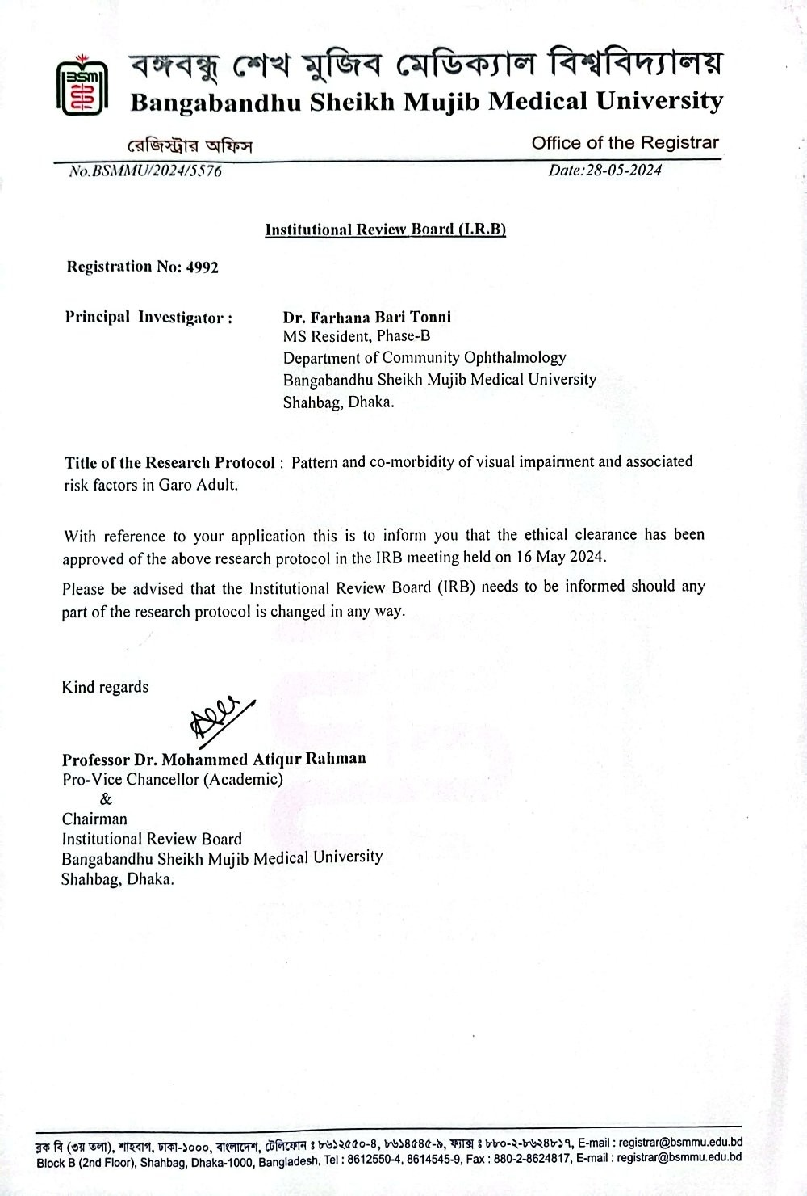

APPENDIX-II
Department of community Ophthalmology, BMU

Title: pattern and co-morbidity of visual impairment and associated risk factors in Garo Adult

Informed Written Consent

Name of Investigator: Dr. Farhana Bari Tonni Mobile no of Investigator: 01621173309
- Protocol ID:
- Patient’s Name & ID:
- Title of the Study: Pattern and co-morbidity of visual impairment associated risk factors in Garo Adult”
- Purpose of the study: The aim of the study to determine the pattern and co-morbidity of visual impairment associated risk factors in Garo tribe.
- Procedure of the study: If you agree to participate in this study, we will ask you some questions and do some examinations.
- Purpose of informed consent: To give information to the participant that will help to understand about the study and thus he/she can participate in this study.
- Benefit and usefulness: In future, data obtained from this study will be used as a baseline study for further research.
- Risk during surgery: No surgical procedure will be done for this study.
- Privacy, anonymity and confidentiality: We ensure that all information provided by the study subjects will be kept confidential and only be used for the purpose of the study. Keeping anonymity data can be given to other researchers for analysis. Information will be disclosed if law and order issue arise.
- Feedback: You can ask any question about anything. I will try to provide you with necessary answers.
- Right to withdraw: You are free to take part or withdraw yourself from the study at any point of time. If you free fairly participate in the study, please submit by signing or putting your left thumb impression at the specified space below.
- Participation: Participation in this research totally dependent upon your complete consent. If you want to participate in this research you have to sign/give finger print in following specific area.
- Consent Confess: I have consulted & gave my appreciation about the research work to the researching doctor. It is my understanding that the participation in this research is completely voluntary & I can withdraw myself from this research at any time without any obligation. I have read above conditions/it was read to me & voluntarily gave my consent to participate in this research.

Thank you for your co-operation.

Investigator | Participant | Witness
Name- | Name- | Name-

Sign/Lt thumb impression | Sign/Lt thumb impression | Sign/Lt thumb impression
Date- | Date- | Date-

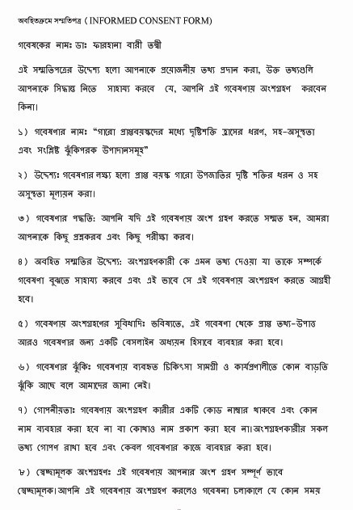
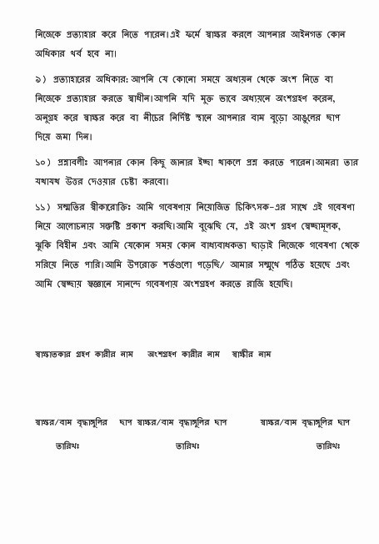

APPENDIX-III

DATA COLLECTION SHEET

Department of Community Ophthalmology, BMU

Title: Pattern and co-morbidity of visual impairment associated risk factors in Garo Adult.
Principal Investigator: Dr. Farhana Bari Tonni

A) Particulars of the patient:

PATIENT ID NO :

1. | Name
2. | Age
3. | Sex
4. | Religion
5. | Address
6. | Contact number
7. | Date of examination
8. | Education

BASELINE EVALUATION:

B. History:
- Presenting complaints:

- Past history:

• | Any other ocular disease- | Yes /No 
• | Any ocular therapy or surgery- | Yes /No 
• | Any ocular injury- | Yes /No 
• | Any systemic disease like diabetes, hypertension, etc- | Yes /No 
• | Any upper GI disease or intervention | Yes /No 

- Drug history:
  - Use of any systemic or topical drug- Yes /No 

  - History of drug allergy- Yes /No 

- Personal history:

• | Cigarette smoking- | Yes /No 
• | Alcohol consumption- | Yes /No 
• | Betel Nut / Leaf– | Yes /No 
- Family history:
  - Ocular disease- Yes /No 
  - Systemic disease- Yes /No 
- status of housing

• | Brick build | Yes /No 
• | Bamboo made | Yes /No 
• | Wooden | Yes /No 

- Use of sanitary latrine Yes /No 
- proper nutrition Yes /No 

C. Physical examination General:
Appearance : Normal/Others
Cooperation : Cooperative/Non cooperative
Anemia : Present/Absent
Jaundice : Present/Absent
Cyanosis : Present/Absent
Oedema : Present/Absent
Dehydration : Present/Absent
Any infection :
Blood pressure
Systolic (mm of Hg) :
Diastolic (mm of Hg) : Pulse (per minute) :
Temperature (degree F) :
Thyroid Gland :
Lymph nodes :

Systemic review:
Cardiovascular system :
Respiratory system :
Nervous system : Musculoskeletal system : Alimentary system :

D) Ocular examination:

Parameter |  |  | R/E | L/E
Visual Acuity | Distance | Unaided
 |  | Aided (if)
 |  | BCVA
 | Near | Unaided
 |  | Aided (if)
 |  | BCVA
Color Vision
Visual Field
Hirschberg reflex
Pupillary light reflex
Slit Lamp Examination
Ocular adnexa
Eyelids
Conjunctiva
Cornea
A/C
Iris
Pupil
Lens
Other ocular morbidity
Direct Ophthalmoscopy

Checked by- Done by-
APPENDIX-IV

Work schedule:

 |  | 2  0  2  3 | 2024 |  |  |  |  |  |  |  |  |  |  |  | 2025
 |  | December | January | February | March | April | May | June | July | |August | September | October | November | December | January | February | March | April | May | June | July | August | September
1 | Topic  Selection
2 | Approaches to  Problem
3 | Writing Protocol
4 | Approval of  Protocol
5 | Data  Collection
6 | Data  Analysis
7 | Report writing  and Bindings
8 | Submission

APPENDIX- V

Flowchart (Describe sequence of tasks within time frame):

Topic selection – December 2023

Approach to problem- January 2024

Writing protocol - February to April 2024

Approval of protocol - May 2024

Data collection – June 2024 to July2025

Data analysis – August 2025

Report writing and binding –September 2025

Submission –September 2025

APPENDIX- VI

Detailed budget:

SL  No | Expense Item | Quantity | Unit Cost (BDT) | Total (BDT)
1 | Administrative expenses
2 | Tools and materials
 | a) Pen and notepad | 50 | 30 | 1,500
 | b) File | 20 | 50 | 1,000
 | c)A4 paper | 10 | 500 | 5,000
 | d)Photocopy |  |  | 30,000
 | e)Ink cartridge | 6 | 1500 | 9,000
 | f)Binding and compose |  |  | 30,000
 | g) Instrument |  |  | Provide by Department
3 | Data Analysis |  |  | 30,000
4 | Transport |  |  | 50,000
5 | Research assistant | 2 |  | 50,000
 | Misc expenditure |  |  | 15,000
 | Total |  |  | 2,21,500

In words: Two Lac Twenty One thousand Five Hundred Taka only.

APPENDIX- VII
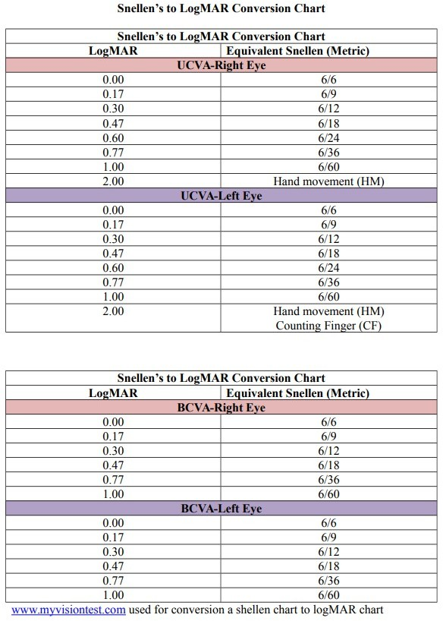

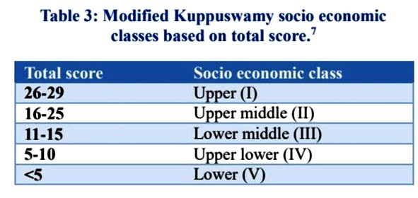
APPENDIX- VIII

Modified Kuppuswamy socioeconomic scale 2023; stratification and updates
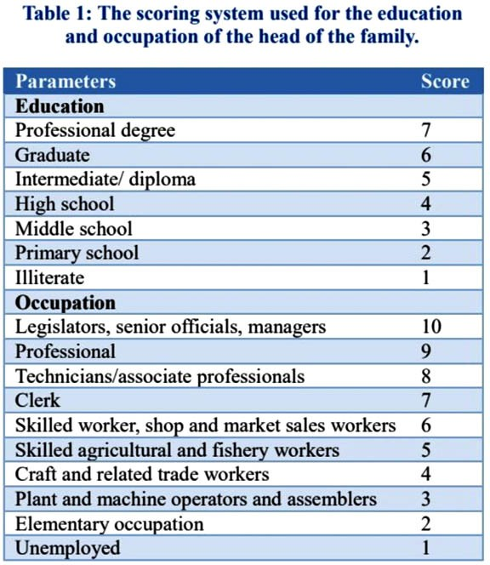

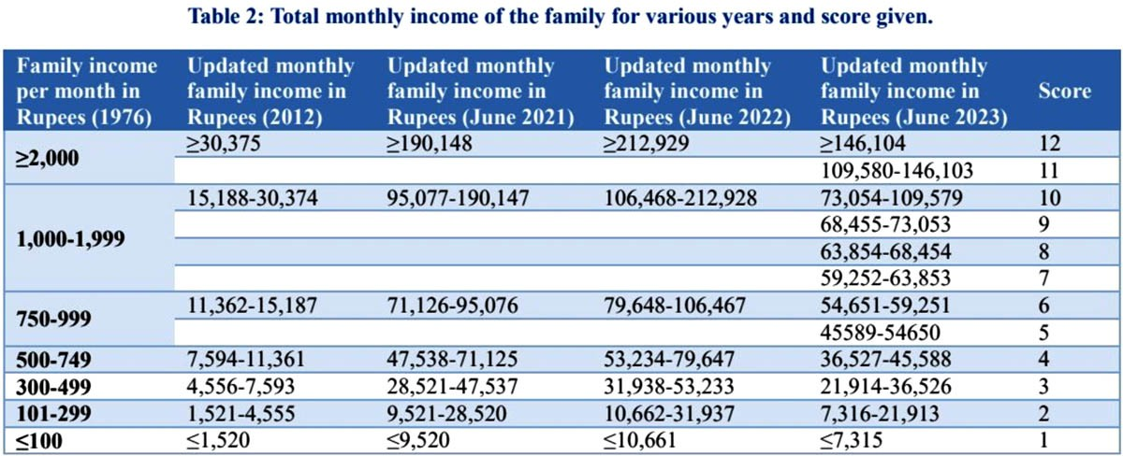

APPENDIX-IX

Statistical Formula

- Mean ( X )= ^{x1 + x2 +} ^{+ xn}
n

- SD=
Σ( X – X ) ²
(n – 1)

SD= Standard Deviation X=Observation
X=Mean
n= Number of observation

Logistic Regression formula Preconditions:
One dependent variable-(must be qualitative and binary outcome)
One or more independent variable (may be binary, categorical, quantitative) Dependent variable expressed as the probability of positive outcome in log transformation (log of odds of probability of positive outcome.

Log of odds=Log
P

1 – P
When P=Probability of positive outcome
Risk ratio (OR or RR) of each independent variable with respect to the dependent variable is calculated and expressed in log transformation which is accounted as their regression coefficient.

Y=a+b₁x₁+b₂x₂….b_{n}x_{n}
Y=log of odds of positive outcome
x₁,x₂---x_{n} are predictors (independent variable)
b₁, b₂, b_{n} are log of risk ratio of respective predictors.

APPENDIX-X
Acceptance letter from local chairman
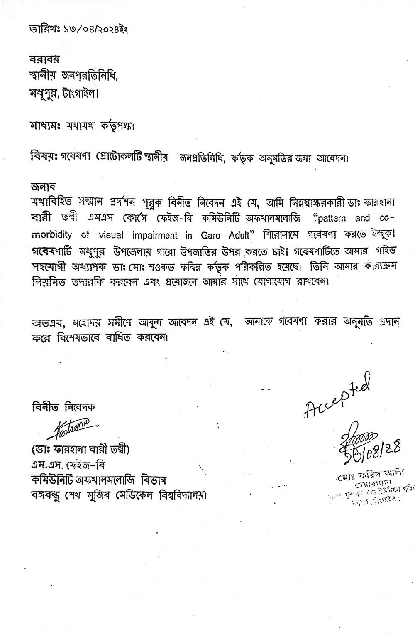

APPENDIX-XI

Certificate of Plagiarism Check
